FOR IMMEDIATE RELEASE
DATE: August 24, 2015
CONTACT: Laura Cavazos
PHONE: (956) 212-8297
E-MAIL: laura@wfsolutions.org

Workforce Solutions Releases July Labor Market Report

McAllen, TX – McAllen had the lowest reported unemployment city rate, at 5.2%, followed by Edinburg with 5.5%. Harlingen was third at 6.1%. Laredo had the lowest in the border region, at 4.5%.
Aside from the significant job losses reported in the Government sector, there were slight net job gains in Retail, Transportation and Healthcare sectors.
The national and state unemployment rate remained unchanged from the June levels of 5.3% and 4.2%, respectively.
"The RGV continues to see a normal seasonal increase in the unemployment rate during the summer mostly in the public education sector which is likely due to the summer break," said Francisco Almaraz, Chief Executive Officer Workforce Solutions. "The good news for the economy in the Rio Grande Valley is the steady growth in trade and transportation with over 400 jobs added this month in Hidalgo County alone.”

At the state level, the Texas Workforce Commission showed a seasonally adjusted net loss of only 200 Oil and Gas jobs in July. Given the recent decline in oil prices, we may see yet another round of job losses in the coming months.

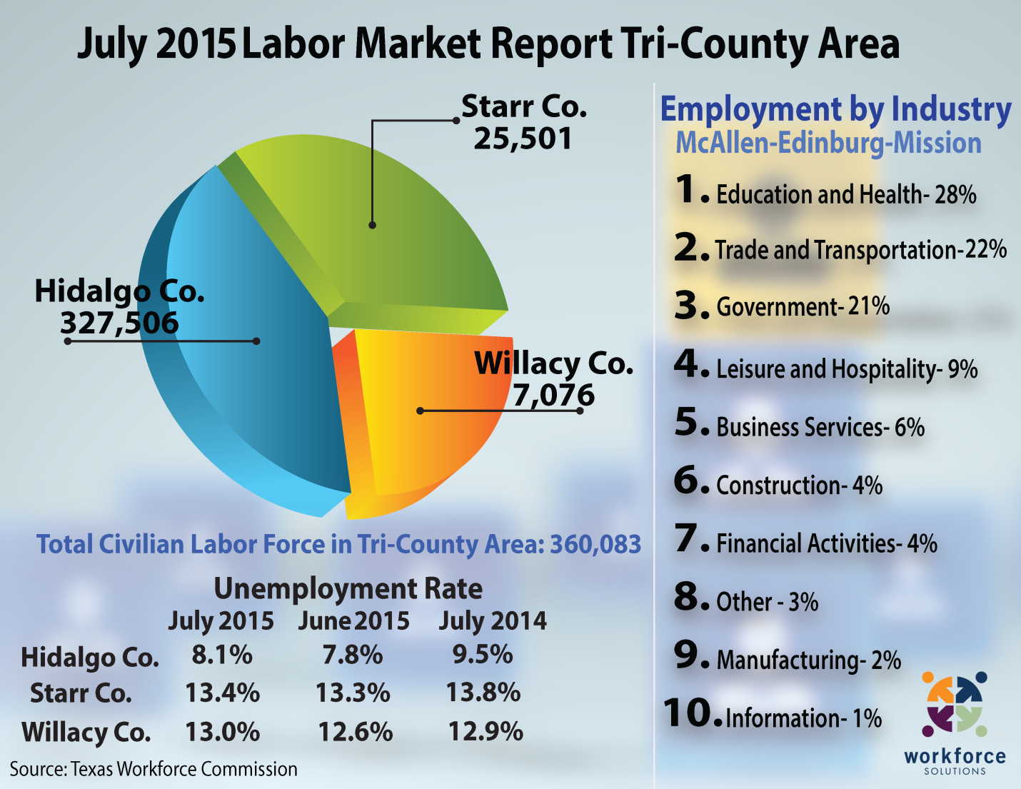
Employment estimates released by TWC are produced in cooperation with the U.S. Department of Labor’s Bureau of Labor Statistics. All estimates are subject to revision.

Workforce Solutions
Workforce Solutions (WFS), under the direction of the Texas Workforce Commission (TWC), is one of 28 local workforce boards located throughout the state. This workforce board services Hidalgo, Starr, and Willacy counties. The primary goal of TWC and the 28 workforce boards is to respond to needs of Texas employers and workers through locally designed market-driven workforce development initiatives and services. All employers, workers, and job seekers are encouraged to take advantage of these services. To learn more about the programs and services WFS has to offer, please call (877) 687-1121 or visit WFSolutions.org.

###

\

